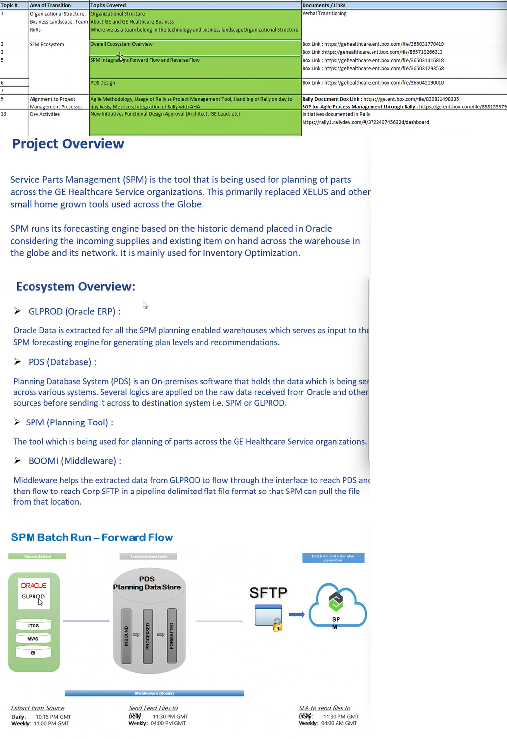

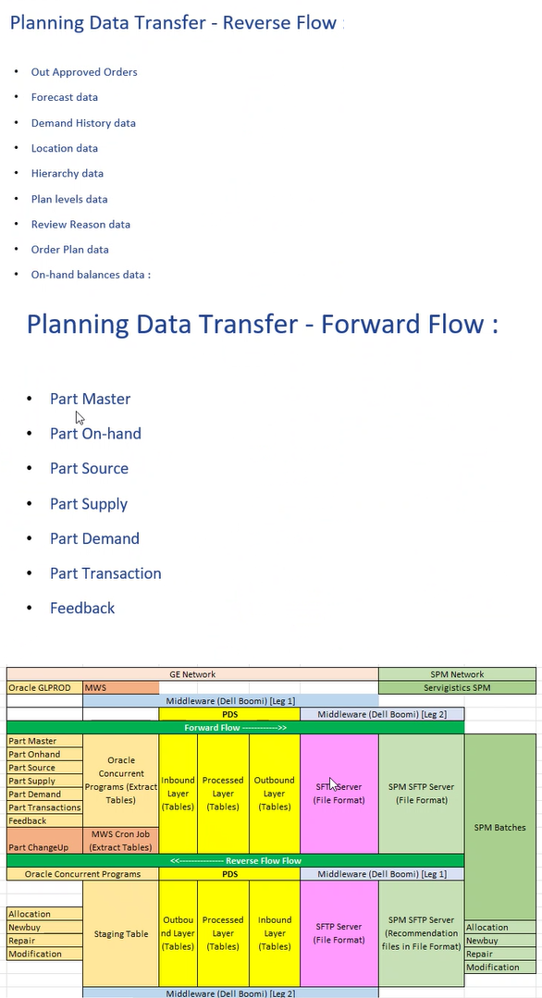

SPM planning tool which plans the parts of GE healthcare.

XELUS: previous application,

after 2016: migrated to spm

goes across the inventory wrt demand.

glprod: erp system, oracle to extract the required data, on that data spm plans.

glprod-> is the data source, oracle erp instance

pds-> intermediate database between glprod and spm, messages the data

spm-> plans the parts

boomi-> boomi is used to interconnect between the 3 other databases.

etl tool

glprod(oracle/ supplier connect) to pds(inbound->processed->formatted(spm layer))

file prepared put on ge sftp server, file sent to spm outside ge.

From oracle to spm, we call forward flow

spm-> oracle: reverse flow.

part master: details of all the parts

on hand: parts in which inventory

source: internal/external supplier details

supply: purchase order details

demand: sales order

transaction:

feedback

Forward flow

Reverse flow:

recommendations come from out approved orders, needs to be processed as soon as we receive it.

forecast data: what forecast spm has done

demand history:

location

-----------

on daily basis concurrent programs

procedures written to glprod, takes data from oracle base/ standard tables, populates the feed tables.

concurrent tables runs and puts it on feed tables.

then inbound layer(pds database)

processed, outbound layer,

boomi will take data, prepare a flat file and sent it on sftp server.

then data sent to spm sftp server.

spm receives data, runs spm batches and generates 4 kind of recommendations and puts back on spm sftp server,

2 interfaces: one sends from ge sftp to spm sftp server

one sends in reverse

thus one batch gets completed

glprod and part changeup(myworkshop) are the two data sources.

on top of the forecast details, we extract , forecast for one external supplier, and send the collaborative planning to external.

intellicus reports generates few reports, places on a report folder of spm sftp server(reports folder)

middleware -> batch related

globalscape-> report related

we put them in the ge library.

last part exists but not runs.

Architecture.

We do the coding on inbound, processed and outbound layer.

request access

rally

rally request project access

part of spm devops team

gehc devspark workspace

project access: spm devops support

add request

Concurrent programs: programs can be run from oracle erp frontened, parameters can be given while running the program

glprod erp system: glprod is the name of production instance of erp

gltest: instance but for testing

multiple warehouses

glprod to spm data flow:

svc: service

Onhand program: extract onhand info for all gprs enabled organization

screw: 10 q

Take info and send to spm

Onhand we have to send on a daily basis

onhand: whatever we have in hand

supply: what things would come to warehouse

supply data: open supplies(PO, IR)

po: external, internal created by ir

rma: material created by fe

fe:

demand: sales order (open)

supply: purchase order ()

so and po created for a recommendation

reverse flow: spm to glprod

types of recommendation:

allocation: us to india warehouse transfer

new buy: 2 types: internal: where ge manufactures and external: from external vendors

repair: Parts needs to be repaired, from onhand also we can send this, defective parts which fe has collected. fe sends to warehouse, we send as a forward flow to spm, if part repairable spm sends to repair supplier.

modification: spm has sent one of above 3 recommendation, and wants to modify some details inside them.

spm batches: weekly batch(12 hours, full data), sunday(6k orders to glprod, output on monday) and daily batch

Instances and type of instances:

PDS: prd, stg, dev

SPM: prod, test, dev, qa, sandbox

glprod: stage: pre-pod, deploy changes do testing

gltest: every sunday it gets refreshed from glprod

raise a request for spm devops support dl and

operations: how process works